**Form Basics**

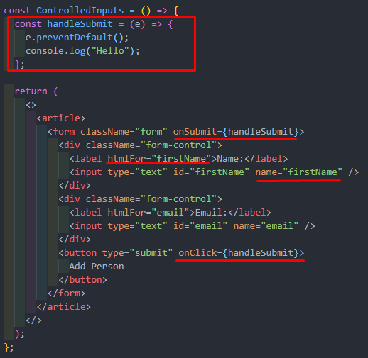

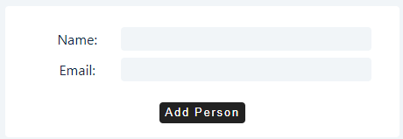 

**Controlled Inputs**

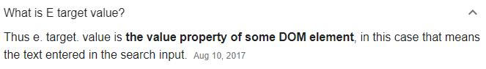

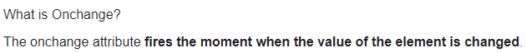

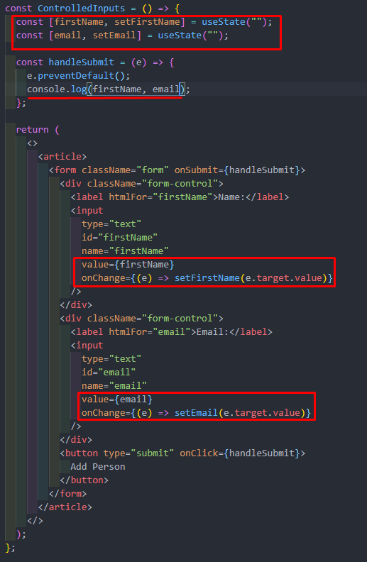

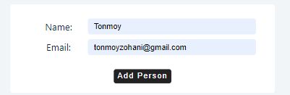

**Add Item to the List**

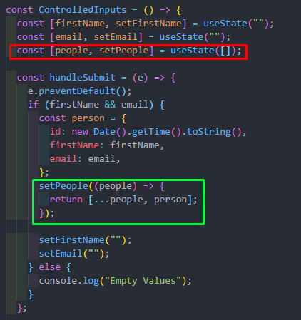

**return (**

**<>**

**<article>**

**<form className="form" onSubmit={handleSubmit}>**

**<div className="form-control">**

**<label htmlFor="firstName">Name:</label>**

**<input**

**type="text"**

**id="firstName"**

**name="firstName"**

**value={firstName}**

**onChange={(e) => setFirstName(e.target.value)}**

**/>**

**</div>**

**<div className="form-control">**

**<label htmlFor="email">Email:</label>**

**<input**

**type="text"**

**id="email"**

**name="email"**

**value={email}**

**onChange={(e) => setEmail(e.target.value)}**

**/>**

**</div>**

**<button type="submit" onClick={handleSubmit}>**

**Add Person**

**</button>**

**</form>**

***{people.map((person, index) => {***

***const { id, firstName, email } = person;***

***return (***

***<div className="item" key={id}>***

***<h4>{firstName}</h4>***

***<p>{email}</p>***

***</div>***

***);***

***})}***

**</article>**

**</>**

**);**

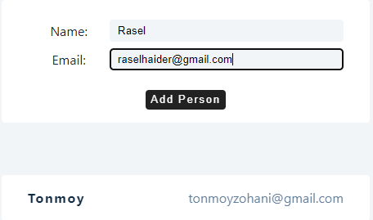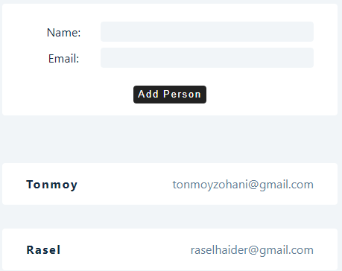

**Multiple Inputs**

const ControlledInputs = () => {

const [person, setPerson] = useState({ firstName: "", email: "", age: "" });

const [people, setPeople] = useState([]);

const handleChange = (e) => {

const name = e.target.name;

const value = e.target.value;

setPerson({ ...person, [name]: value }); *// taking the old values // setting values dynamically*

};

const handleSubmit = (e) => {

e.preventDefault();

if (person.firstName && person.email && person.age) {

const newPerson = { ...person, id: new Date().getTime().toString() };

setPeople([...people, newPerson]);

setPerson({ firstName: "", email: "", age: "" });

}

};

return (

<>

<article className="form">

<form>

<div className="form-control">

<label htmlFor="firstName">Name : </label>

<input

type="text"

id="firstName"

name="firstName"

value={person.firstName}

onChange={handleChange}

/>

</div>

<div className="form-control">

<label htmlFor="email">Email : </label>

<input

type="email"

id="email"

name="email"

value={person.email}

onChange={handleChange}

/>

</div>

<div className="form-control">

<label htmlFor="age">Age : </label>

<input

type="number"

id="age"

name="age"

value={person.age}

onChange={handleChange}

/>

</div>

<button type="submit" className="btn" onClick={handleSubmit}>

add person

</button>

</form>

</article>

<article>

{people.map((person) => {

const { id, firstName, email, age } = person;

return (

<div key={id} className="item">

<h4>{firstName}</h4>

<p>{email}</p>

<p>{age}</p>

</div>

);

})}

</article>

</>

);

};

